 | ALL SAINTS’ COLLEGE  Ewing Avenue, Bull Creek, Western Australia
 | HUMAN BIOLOGY

Year 11 2006 Semester II Examination Question/Answer Booklet

C.C. STUDENT NUMBER - In figures 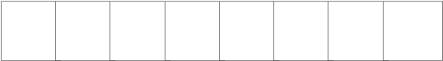

TIME ALLOWED FOR THIS PAPER
Reading time before commencing work: Ten minutes
Working time for paper: Three hours

MATERIALS REQUIRED/RECOMMENDED FOR THIS PAPER

TO BE PROVIDED BY THE TEACHER
This Question/Answer Booklet
Separate Multiple Choice Answer Sheet
Standard Answer Booklet

TO BE PROVIDED BY THE CANDIDATE

Standard items: Pens, pencils, eraser or correction fluid, ruler and highlighter.

Special Items: A 2B, B or HB pencil for the separate Multiple Choice Answer Sheet and calculators
satisfying the conditions set by the Curriculum Council.

IMPORTANT NOTE TO CANDIDATES

No other items may be taken into the examination room.

It is your responsibility to ensure that you do not have any unauthorized notes or other items of a non-personal nature in the examination room. If you have any unauthorized material with you, hand it to the supervisor BEFORE reading any further.

STRUCTURE OF THIS PAPER

Part | No. of questions available | No. of questions to be attempted. | Marks available | Student’s Score
I Multiple choice | 40 | ALL | 80
II Diagram and short answer  questions | 8 | ALL | 80
III Extended answer questions: A  B | 2  2 | 1  1 | 20  20
Totals |  |  | 200

INSTRUCTIONS TO CANDIDATES

PART I Answer ALL questions, using a 2B, B or HB pencil, on the separate Multiple Choice Answer Sheet. Do NOT use a ball point or ink pen.

PART II Should be answered in this Question/Answer Booklet. Write your answers in the spaces provided, using a blue or black ballpoint or ink pen. Draw any diagrams in pencil.

PART III Should be answered in the Standard Answer Booklet. Use a blue or black ballpoint or ink pen. Draw any diagrams in pencil.

PART I (80 marks)

Mark your answers to Questions 1-40 on the SEPARATE MULTIPLE CHOICE ANSWER SHEET, using a 2B, B or HB pencil. If you make an error, follow the instructions given to you on the answer sheet.

SELECT THE SINGLE CORRECT ALTERNATIVE IN EACH OF THE FOLLOWING QUESTIONS

- A student was examining some epithelial cells from the palm of her hand. She observed some rectangular shaped cells similar to those in the diagram below. For this particular microscope the diameter of the field of view is 1800 μm at low power (100x).

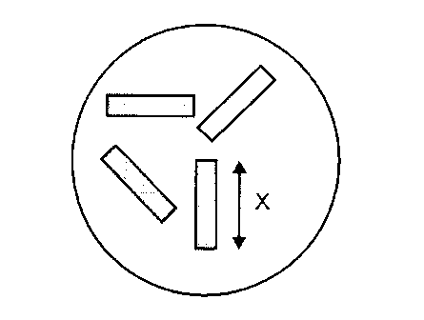
She changes the objective lens to the 40x. This increases the microscope’s total magnification to 400x. The length of ONE cell would be approximately

  - 1800 μm
  - 600 μm
  - 450 μm
  - 150 μm

- During the preparation of an onion plant epidermis, a student used an iodine stain. He then examined the slide preparation under low power of a light microscope. The purpose of the iodine stain is to

  - kill the cells.
  - show the structure of the cell organelles.
  - allow the chromosomes to be clearly seen.
  - provide contrast between structures of the cell.

- Which of the following hormones acts on the testes?
  - Luteinising hormone.
  - Oestrogen.
  - Human Chorionic Gonadtrophin.
  - Prolactin.
- Increased secretions of progesterone will
  - cause the release of an ovum.
  - cause menstruation
  - increase the thickness of the uterine lining.
  - enhance fertilization.

- Which one of the following occurs during days 15 to 28 of the (female) ovarian cycle?

- Ovulation.
- Lutenising hormone secretion peaks.
- Follicle Stimulating Hormone decrease.
- The corpus luteum secretes progesterone.

- Seminal fluid

  - provides nutrition for the ovum.
  - causes contraction of the uterus.
  - neutralises the acidic nature of the vagina.
  - develops secondary sexual characteristics.

- Blood enters the femoral artery from the
- aorta.
- renal artery.
- carotid artery.
- coronary artery.

- Lymph enters the circulatory system at the
- hepatic vein.
- jugular vein.
- coronary vein.
- subclavian vein.

Use the following diagram to answer questions 9 to 11.

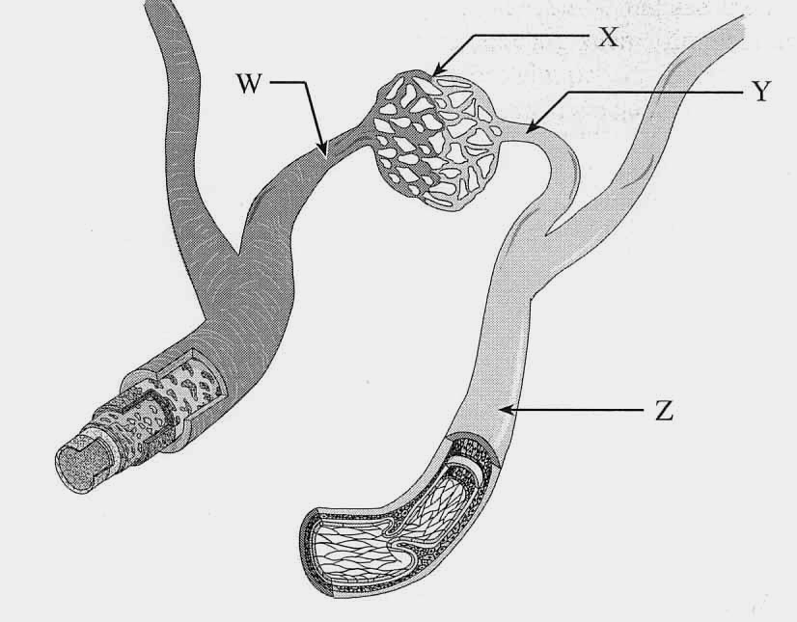

- Which structure would be classified as a venule?

- W
- X
- Y
- Z

- Structure ____ contains blood with the highest concentration of hydrogen carbonate ions.

- W
- X
- Y
- Z

- Which blood vessel can constrict to cause an increase in blood pressure?

- W
- X
- Y
- Z

- Lacteals absorb

- fats.
- peptides.
- carbohydrates.
- glucose.

- A decrease in secretions from the gallbladder would cause a/an

- increased gastric secretions.
- increased peristalsis in the digestive tract.
- decreased water absorption.
- decreased incidence of glycerol in the small intestine.

- Which of the following substances would be found in person’s stomach after a ‘balanced’ meal?
- Water, salts, maltase and bile.
- Starch, glycerol, amylase and trypsin.
- Protein, pepsin, hydrochloric acid and maltose.
- Hydrochloric acid, peptides, bicarbonate ions and bile.

- Both veins and lymph vessels

- contain valves.
- return blood to the heart.
- have thick elastic walls.
- carry low oxygenated blood.

- Which of the following illustrates the increasing complexity of levels of organisation in humans?

- organelle, cell, tissue, organ, system, organism.
- cell, organelle, tissue, organ, system, organism.
- organelle, tissue, cell, organ, system, organism.
- cell, system, organ, tissue, organelle, organism.

Use the following diagram to answer questions 17 to 18.

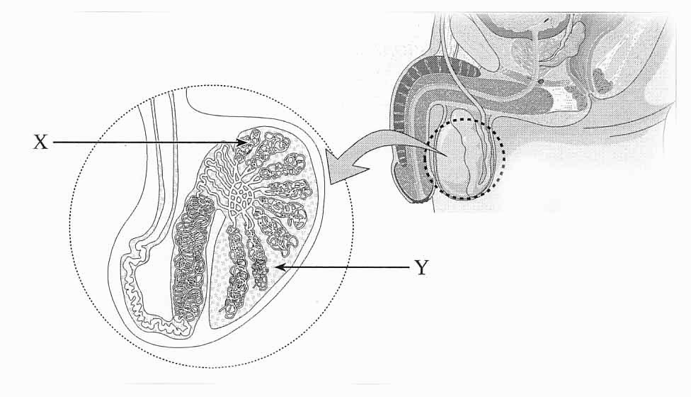

- The function of the substance produced at Y
- fertilises the egg.
- neutralises that acidity of the vagina.
- provides sperm nourishment.
- enhances muscular development.

- The ‘cells’ stored in X move to the
- urethra.
- epididymis
- vas deferens.
- seminal vesicles.

- The brain, kidney and liver all develop from the zygote. This indicates that cells formed by divisions of the zygote are able to

  - differentiate.
  - mutate.
  - replicate.
  - change.

- A diet high in salt will cause

- arthritis
- high blood pressure.
- irregular menstruation.
- obesity.

- Smooth muscle tissue

- is always attached to the skeleton.
- contains multi-nucleated cells.
- forms the walls of the heart.
- is found in the walls of veins.

- Adenosine tri-phosphate is formed in the
- endoplasmic reticulum.
- mitochondria.
- ribosomes.
- golgi body.

- A synovial joint would be found between all of the following except

  - two phalanges.
  - two sacral vertebrae.
  - the tibia and femur.
  - the scapula and humerus.

- The outer most layer of long bones is called

- Periosteum.
- Cartilage.
- Osteocytes.
- Cancellous bone.

- The function of a joint ligament is to

  - join the surrounding muscle to the bone.
  - join the bones of the joint.
  - form a flexible capsule around the joint.
  - secrete synovial fluid.

- Atmospheric air moves into the lungs during inhalation because the

  - volume inside the thoracic cavity decreases.
  - volume inside the thoracic cavity increases.
  - pressure inside the thoracic cavity increases.
  - diaphragm relaxes.

- As blood moves through the arterioles to the capillaries and then to the venules, the blood would

- increase its concentration of hydrogen carbonate ions.
- produce more oxyhaemoglobin.
- release carbon dioxide gas.
- increase its concentration of oxygen.

Use the following description to answer question 28

A student designs an experiment to determine the effect of sucrose concentration on the mass of potato cells. The following procedure was used:

- Six equal sized cubes are cut.
- The initial mass of each cube is measured.
- Six test tubes are filled with different sucrose solutions.
- One cube of potato is added to each test tube.
- After one hour, the cubes are removed, dried and weighed.

- One of the solutions was found to be isotonic to the cytoplasm of the potato cells. Why was their no change in the mass of the potato cube in this solution?

  - There was an equal movement of water into and out of the cells.
  - The water and sucrose do not move across the cell membrane.
  - There is an equal movement of sucrose into and out of the cells.
  - There is an equal movement of water and sucrose into and out of the cells.

Use the following graph to answer questions 29.

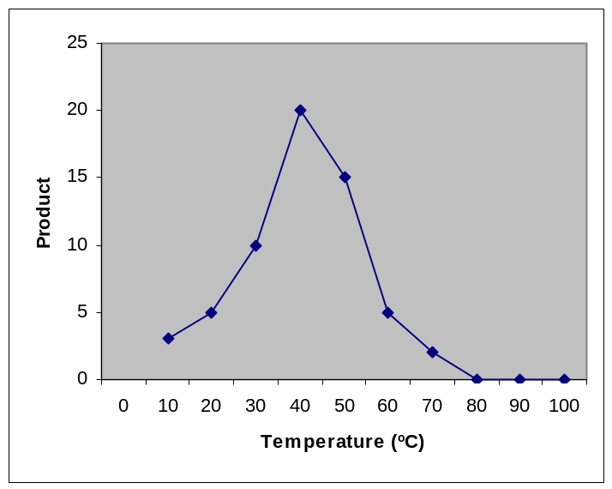

- The above data (product formed) was collected using small intestine enzymes and disaccharides. Which of the following describes the amount of product that will be formed at each temperature if the same experiment was repeated at pH of 4?

  - The amount of product will be the same.
  - The amount of product will be greater.
  - The amount of product will be less.
  - The amount of product cannot be determined due to insufficient information.

- Which of the following primates would not be classified as an Anthropoid?

  - Baboon
  - Gibbon
  - Tarsier
  - Orangutan

- Which of the following is NOT an adaptation to either an upright stance or bipedal locomotion?

  - The central location of the foramen magnum.
  - An enlarged heel bone.
  - A broad and short pelvis.
  - Wedge –shaped thoraric vertebrae.

- New World Monkeys are different from Old World Monkeys due to the presence of

  - a prehensile tail.
  - cheek pouches.
  - ischial callosities
  - two premolars.

- The least amount of oxygen would be found in

  - most venous blood vessels.
  - most arterial blood vessels.
  - atmospheric air.
  - expired air.

- The secretion of progesterone decreases sharply at the end of the female reproductive cycle because

  - ovulation occurs.
  - the zygote has implanted itself in the endometrium.
  - a mature graafian follicle is present.
  - the corpus luteum degenerates.

- The first female oral contraceptive pill developed (and still widely used) is similar in its action to the hormone(s)

  - progesterone.
  - oestrogen and progesterone.
  - follicle stimulating hormone.
  - oestrogen.

- Which of the following describes abduction movement?

  - Movement towards the midline of the body.
  - Movement away from the midline of the body.
  - Bending the arm.
  - Raising the arms above the head in a vertical position.

Use the following diagram to answer questions 37.
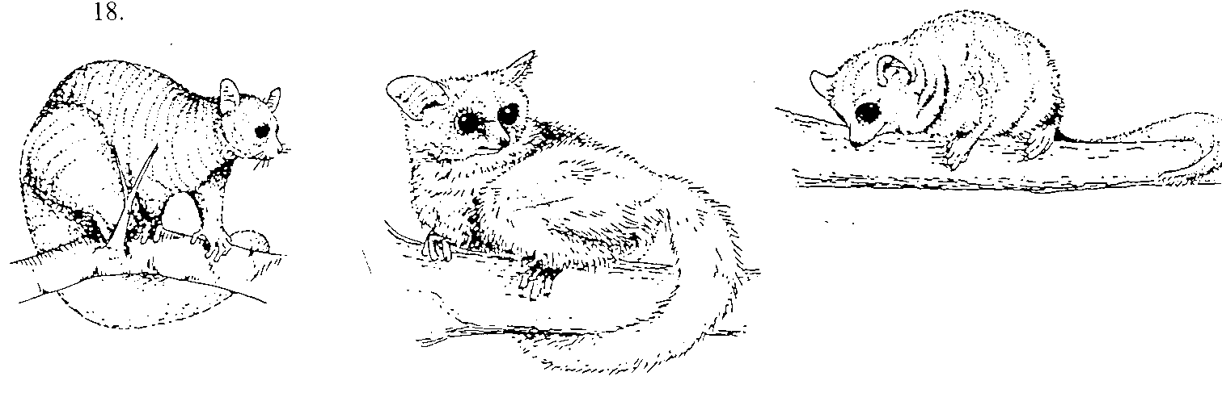

- The primates shown above would be classified as

  - Old World Monkeys.
  - Prosimians
  - Catarrhines.
  - New World Monkeys.

- Many changes occur during the ageing process. Which of the following does NOT happen?

  - The skin becomes wrinkled.
  - The heart rate increases.
  - Bones become less brittle.
  - The ‘joints’ degenerate.

- Within sixteen days of conception, the inner cell mass or embryo has developed three layers.
The ectoderm will form the
- nervous system, epidermis, hair and nails.
- muscle, bone, cartilage and blood vessels.
- glands and linings.
- ectoderm and ectoplasm.

- Arteriosclerosis occurs in

  - the cerebral arteries and is caused by a blood clot.
  - the coronary arteries during a heart attack.
  - all arteries and will lead to an increase in blood pressure.
  - the heart only.

END OF PART I

PART II (80 marks)
Write answers to ALL questions on the ruled lines after each question or in the spaces provided within each table. Write your answers in blue or black ballpoint or ink pen.

QUESTION 41 (Total 7 marks)

(a) Using the table below, clearly distinguish between the following four (4) features for pongids (apes) and humans.

Primate Feature | Pongid | Human
Arm to Leg ratio

Brain Size

Dentition

Pelvis

(4 marks)
- (i) Define the term opposability.

________________________________________________________________________________________________________________________________________________________________
(1 mark)

(ii) Describe how opposability varies in the Primate Order.

________________________________________________________________________________________________________________________________________________________________________________________________________________________________________________________________________________________________________________________________
(2 marks)

QUESTION 42 (Total 10 marks)

The diagram below shows the muscles and bones involved in the movement of the foreman at the elbow joint.

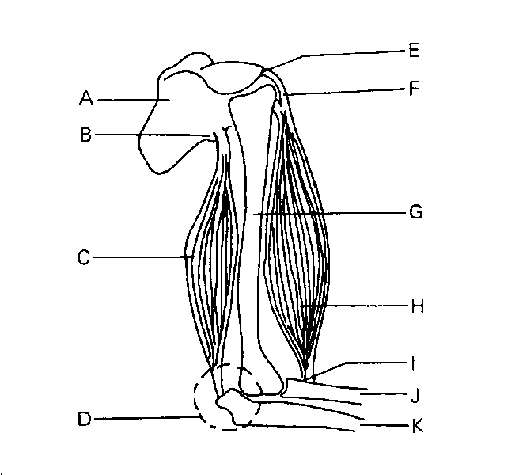

(a) Naming the appropriate labeled structures above, describe how the forearm is raised.

_________________________________________________________________________________________________________________________________________________________________________________________________________________________________________________________
____________________________________________________________________________________________________________________________________________________________________________________________________________________________________________________________________________________________________________________________________________

(6 marks)

(b) The skeletal aspects of the foot and knee have undergone changes or adaptations to facilitate bipedal locomotion. Select ONE adaptation of the foot and knee and describe how they assist bipedal locomotion.

____________________________________________________________________________________________________________________________________________________________________________________________________________________________________________________________________________________________________________________________________________
______________________________________________________________________________________________________________________________________________________________________
(4 marks)

QUESTION 43 (Total 10 marks)

The diagram below shows several red blood cell.



- What is the name of the red pigment found in red blood cells? ___________________________

(1 mark)

- Explain how this substance assists red blood cells in carrying out their function

__________________________________________________________________________________________________________________________________________________________________________________________________________________________________________
(3 marks)

The diagram below illustrates the pathway of carbon dioxide in the blood.

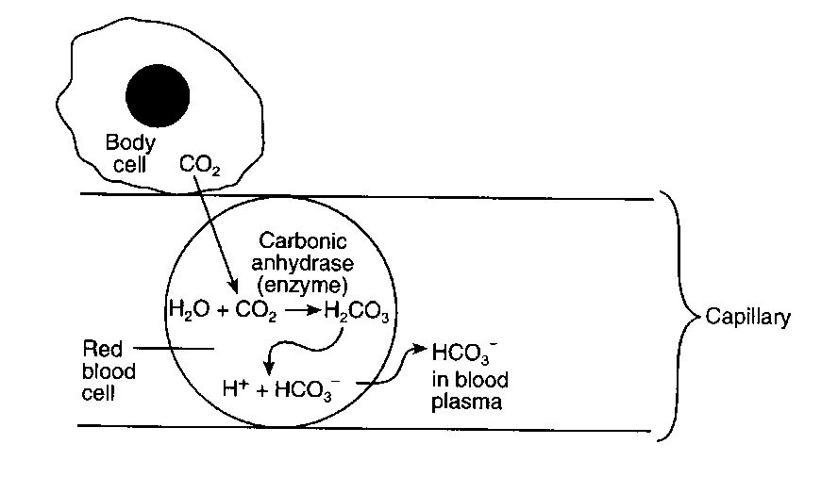
- Identify the cellular process that produced the carbon dioxide in the body cell.

_____________________________________________________________________________

(1 mark)

- Explain why carbon dioxide moves into the plasma by diffusion rather than active transport.

________________________________________________________________________________________________________________________________________________________________________________________________________________________________________________
(2 marks)

- What would happen to the production of hydrogen carbonate ions if carbonic anhydrase were not present in red blood cells?

________________________________________________________________________________________________________________________________________________________________________________________________________________________________________________
(1 mark)

- How could this enzyme’s activity be affected in the body?

________________________________________________________________________________________________________________________________________________________________________________________________________________________________________________________________________________________________________________________________

(2 marks)

QUESTION 44 (Total 10 marks)

The diagram below shows a front view of the chest at the end of breathing in or inhalation.

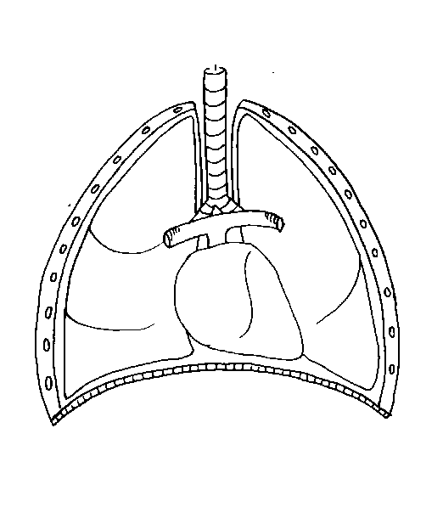

A

B

(a) What is the anatomical term for A?

___________________________________________________________________________________

(1 mark)

(b) What is the anatomical term for the part of the body below A?

___________________________________________________________________________________
(1 mark)

(c) On the above diagram, draw TWO (2) arrows to show the movement of A and B when the person breathes out or expires.
(2 marks)

(d) Describe the pressure changes within the chest area when a person expires and inspires.

____________________________________________________________________________________________________________________________________________________________________________________________________________________________________________________________________________________________________________________

(2 marks)

- What are alveoli?

____________________________________________________________________________________________________________________________________________________________

(2 marks)
- Describe how the structure of alveoli enhances its function.

__________________________________________________________________________________________________________________________________________________________________________________________________________________________________________

(2 marks)

QUESTION 45 (Total 15 marks)

(a) Complete the table below depicting the action of enzymes in the digestive system.
(3 marks)

Enzyme | Substrate | Product
Pancreatic amylase |  | Glucose
Gastric protease | Proteins
Intestinal lipase | Lipids

(b) Dietary recommendations are that lipid intake should make up 30% of energy intake. The recommended energy intake for most women aged 19 to 49 is 8100 KJ per day. The energy content of lipid is 37 KJ per gram. Calculate the recommended lipid intake per day for this age group for women. Show all working.
_________________________________________________________________________________________________________________________________________________________________________________________________________________________________________________________
(2 marks)

In humans, triglycerides are the main form of dietary lipids. They are digested in the small intestine.

(c) Describe a test that could be performed in the laboratory on a food sample to determine whether it contained lipids.

_________________________________________________________________________________________________________________________________________________________________________________________________________________________________________________________
(2 marks)

(d) Explain how dietary fats are absorbed into the small intestine.

____________________________________________________________________________________________________________________________________________________________________________________________________________________________________________________________________________________________________________________________________________
(4 marks)
(e) Describe the role of bile in the digestion of lipids.

_________________________________________________________________________________________________________________________________________________________________________________________________________________________________________________________
(3 marks)

(f) Which part of a cell are lipids a major component?

___________________________________________________________________________________

(1 mark)
QUESTION 46 (Total 8 marks)

- In the table below, describe the role or function of the five (5) cell organelles listed.

Cell Organelle | Function
Golgi Apparatus

Mitochondria

Lysosome

Cell Membrane

Ribosomes

(5 marks)

A student prepared a wet-mount slide of onion epidermis and observed it under high power of a light microscope. After adding a substance to the slide and waiting one minute, the students observed changes in the cells. This is shown below in View B.

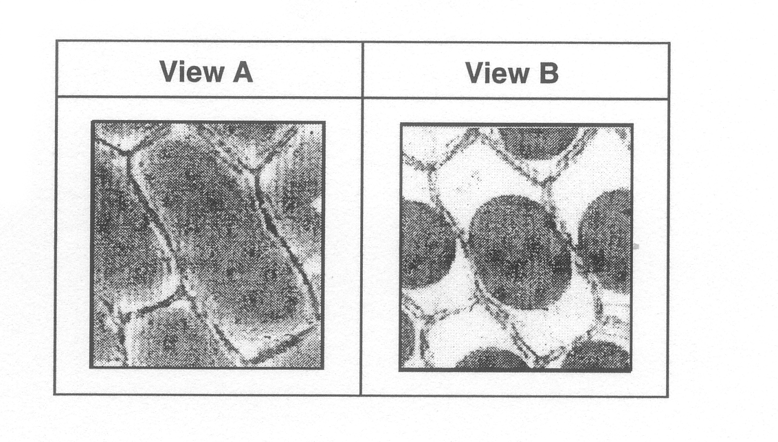

- Identify ONE substance that could have been added to the cells on the slide A that would make them resemble the cells observed in view B.

________________________________________________________________________________
(1 mark)

- In the box below, sketch how View B would appear when viewed under lower power of the same microscope.

(2 marks)

QUESTION 47 (10 marks)
The graph below shows the average motility of sperm cells released by males of different ages.
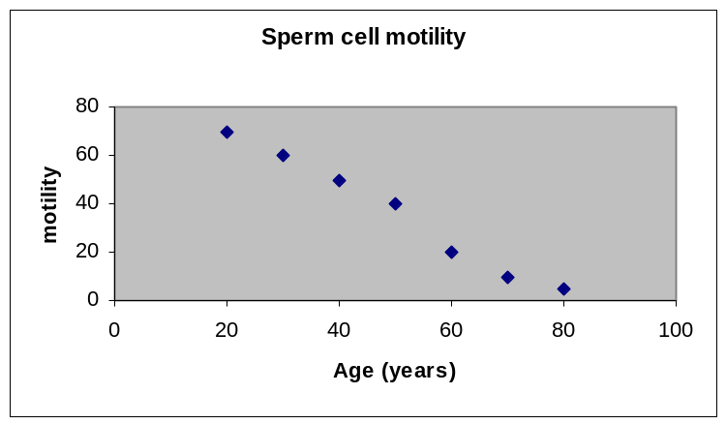

- Describe the pattern or trend shown by the data collected in the graph.

______________________________________________________________________________________________________________________________________________________________________
(2 marks)

- Describe TWO features of a sperm cell that enables it to move.
_________________________________________________________________________________________________________________________________________________________________________________________________________________________________________________________
(2 marks)

- What is meiosis?

______________________________________________________________________________________________________________________________________________________________________
(2 marks)

- Sperm are produced during meiosis. How does this process produce genetic variation in sperm?

______________________________________________________________________________________________________________________________________________________________________
______________________________________________________________________________________________________________________________________________________________________
(3 marks)

- Where do sperm mature?

___________________________________________________________________________________
(1 mark)

QUESTION 48 (Total 10 marks)

The table below shows the volume of oxygen transported to and from the foetus during the final week of pregnancy.

Blood Vessel | Volume of Oxygen transported (ml/gm/minute)
Umbilical Artery | 3.09
Umbilical Vein | 4.81

(a) Using the above data, calculate the rate of oxygen uptake per gram of a foetus with a mass of 3.3kg. Show all working.

_________________________________________________________________________________________________________________________________________________________________________________________________________________________________________________________
(2 marks)

(b) In the final week of pregnancy the placenta stops growing. Suggest why the tissues of the placenta still have a high rate of oxygen uptake.

_________________________________________________________________________________________________________________________________________________________________________________________________________________________________________________________ (2 marks)

(c) During pregnancy, the mother experiences many changes to her body that increases her oxygen consumption. Describe THREE (3) significant physiological changes in her body that cause an increase in oxygen consumption.

__________________________________________________________________________________________________________________________________________________________________________________________________________________________________________________________________________________________________________________________________________________________________________________________________________________________________________________________________________________________________________________
(3 marks)

(d) HCG is a hormone involved in early pregnancy. It can be used as a pregnancy test as it appears in the mother’s blood.

The following figures show the levels of HCG in a sample of female blood over a period of forty days.

Day | 1 | 5 | 10 | 15 | 20 | 25 | 30 | 35 | 40
HCG units | 0.5 | 0.5 | 0.5 | 1.5 | 12 | 15 | 15 | 15 | 15

i) What does HCG stand for?

___________________________________________________________________________________
(1 mark)

ii) Explain why the presence of HCG indicates that the female is pregnant

___________________________________________________________________________________
(1 mark)

iii) During the third month of pregnancy, the levels of HCG decline. Why does this happen?

___________________________________________________________________________________
(1 mark)

END OF PART II
PART III (40 marks)

Answer ONE question from SECTION A and ONE question from SECTION B. Illustrate your answers with diagrams where appropriate. Up to TWO MARKS may be deducted for poorly structured answers: that is, answers in point form or diagrams not explained in the text of your answers. DO NOT WRITE ANSWERS IN PENCIL. Write your answers on the lined pages the Standard Answer Booklet that has been provided.

SECTION A.

ANSWER EITHER QUESTION 49 OR QUESTION 50 – NOT BOTH

QUESTION 49 (Total 20 Marks)

(a) Using examples of primates in existence today, discuss FIVE (5) characteristics with examples that demonstrate the evolutionary trends within the primate order.

(10 marks)

(b) The respiratory system supplies the cells with oxygen and removes harmful carbon dioxide. However, it can be seriously damaged by environmental agents. What is emphysema and asthma? Discuss the cause, symptoms and any possible treatments for these two serious disorders. (10 marks)

OR

QUESTION 50 (Total 20 Marks)
(a) Humans possess one circulatory system yet it is composed of the systemic and pulmonary circulation. Describe the pathways and purpose of the two circulations and briefly mention the role and pathways of the hepatic portal system in the systemic circulation.

(10 marks)

(b) The small intestine is composed of three sections: the duodenum, jejenum and ileum. Discuss the digestive processes and structure of these organs that enhance their role in digestion and/or absorption. What nutrients are absorbed from these sections of the small intestine?

(10 marks)
SECTION B

ANSWER EITHER QUESTION 51 OR QUESTION 52 – NOT BOTH

QUESTION 51 (Total 20 Marks)

a) Enzymes play a major role in the alimentary canal. Discuss how enzymes work and the factors that can affect their functioning.
(10 marks)

b) Syphilis, gonorrhea, chlamydia, herpes and human immunodeficiency (HIV) are five common Sexually Transmitted Infections (STIs). Discuss the effects and any treatments available for these STIs.
(10marks)

OR

QUESTION 52 (Total 20 Marks)

- Kallman’s Syndrome is a rare disorder affecting the hypothalamus and pituitary gland that delays or stops an individual going through puberty. Name the hormones that would be directly affected by this disorder and why an individual would not experience puberty. Contrast this disorder with an individual experiencing ‘normal’ puberty. Describe FOUR (4) changes experienced by both sexes.

(10 marks)

- Cellular respiration is the process by which glucose is broken down to produce energy or adenosine triphosphate (ATP) in the cells. Compare the TWO types of cellular respiration including where it occurs, any reactants and products and the relative amounts of energy produced.

(10 marks)

END OF PAPER

